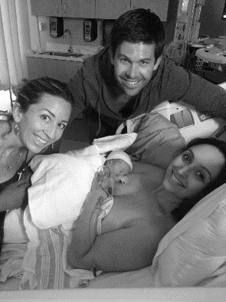
TEMECULA HYPNOBIRTHING/KAREN BRANN’S
BIRTH DOULA CLIENT CONTRACT

What is my role as your doula?
As a birth doula, I will accompany you in labor to help ensure a positive birth experience. I provide physical, emotional, and educational support. During labor, I can help you stay informed so you are able to make decisions and advocate for yourself. I can provide reassurance and perspective to you and your partner, make suggestions for labor progress, and help with relaxation, affirmation and encouragement, massage, positioning and other techniques for comfort and optimal baby-to-pelvis positioning. I can also use Acupressure (I am Acupressure Certified) and Essential Oils to help increase labor efficiency and comfort. I do not perform clinical tasks, such as blood pressure, fetal heart checks, or vaginal exams. As your doula, I am working for you, not your caregiver or the hospital. I am independent and self-employed. I am also a Lactation Educator (CLEC), and so I will provide breastfeeding education and some counseling. I am a HypnoBirthing Educator, so I often incorporate those tools. I am also educated in other methods and will be a support to if you chose any other birthing-style as well.

About my Services
If and when you choose me as your birth doula, I request a $450400 retainer payment, to ensure that we are committed as doula and client. We will then schedule two prenatal meeting which will take place at your home around your 34week and 37week gestation. Will create your birth preferences, talk about your expectations, explore the choices for coping best with labor, and discuss any concerns about the upcoming birth. I’ll be very grateful for the opportunity to go deep and face your fears, address them, and replace them with confidence and peace. We will remain in contact by phone and email until the birth. If you decided to have an induction, I require we have an additional prenatal meeting to discuss how that will change expectations and help you have the best possible induction, this shouldn’t take more than an hour. So even if it’s a decision made the day-of, please make sure you make time to talk to me before going into the hospital. I prefer you call me when you think you are in labor, even if you do not yet need me. This allows me to plan my day and arrange childcare for my children. I need anywhere from 30-90 minutes to get to you from the time you ask me to come. Hopefully there will be some heads-up notice so it can be closer to the 30 minute mark. I will stay with you throughout labor and birth and one to two hours postpartum. After the birth, I can help with initial breastfeeding, if necessary, and answer questions about the birth and your baby. A few days after the birth, I will check on you again for a brief postpartum visit to offer breastfeeding support, referrals, and to address any initial postpartum concerns. I would like to see how you are doing, to review the birth, and get feedback about my role.
I welcome calls as your baby grows about anything else you would like referrals, tips, or regular mom-to-mom help with.
The remainder of my fee is $450400 and is due at the last prenatal, a postdated check is perfectly fine if need be. Sometimes people would like to get that payment out of the way, so a postdated check at the last prenatal would be sensible if you’d rather do that. My full birth doula fee is $900800 This fee is completely separate from the full HypnoBirthing series that I teach, but it includes a discount for taking the full course.

What If?
I will make every effort to provide the services described here. Sometimes this is impossible. I regularly work with other doulas for back up and I will keep you informed if there are any potential reasons that I cannot attend your birth, such as illness, family emergency, or another client’s birth. I have selected a special back up doula who is on call for you. Because there’s no reason for me to expect to miss your birth, usually we don’t ask them to come to a prenatal. However, please feel free to contact them and do a facetime/skype visit if you like. If I cannot attend your birth and you use the backup doula I’ve arranged with you, you can still pay me the remaining fee and I will pay her appropriately. I will also attend the postpartum follow up visit. If a backup doula attends your birth for a short amount of time (for example, maybe it is a long birth and I need a break) you do not need to worry about paying her.
In the unlikely event that I cannot attend your birth due to my error, there will be no charge for my services and I will refund the $450400 retainer fee.
If I do not attend your birth due to circumstances beyond anyone’s control such as a rapid labor, an emergency, preterm birth, or I’m at another birth and you choose not to use the backup doula, as long as we have done a prenatal appointment, I will keep the $450400 retainer fee but there will be no further charges. I will also visit and give support at a postpartum meeting if you would like. In addition, I will be on call for you for any breastfeeding questions anytime. If I do not attend your birth because you do not contact me or change your mind about using my services at your birth, you will be responsible for the full birth doula fee of $900800 as scheduled.
If your pregnancy results in a scheduled cesarean birth, I do believe that doula services are of great help, especially in advocating for Family Centered Cesareans. I will still attend the birth and offer valuable informational and emotional support as well as immediate postpartum and extra postpartum support once you return home.
I will be on call for you 24 hours a day from the time I receive signed contract. I will be available if I can be at your birth happens outside of the normal 38-42 week range; however, I reserve the right to make traveling plans and other commitments outside of those days.

Contact Info
It is okay to have one or more false alarms, “practice labor” happens to a lot of people. Please do not hesitate to call me if you think labor is on the horizon. I would rather be ready to go and not needed than have very late notice once I am needed. We will go over the difference between early labor and active labor. It is typical that I do not come to attend your labor until you are in active labor, but that definition is vague and I am happy to be there as soon as you think you need me. It is not up to me to decide when I should come, but I will help you understand when it is best for me to come if you are unsure. Please give me a heads up so that I can be ready to go at the drop of a hat, so to speak, once you think it could be getting close to time. I will let you know how quickly I should be arriving as I am on my way and hope to arrive before you feel it’s time to leave for the hospital. Please try and avoid a temptation of leaving for the hospital before I get there, unless of course, birth is imminent.

As long as you are not in labor and you have more than a few questions, please email me: karen@temeculahypnobirthing.org
If I do not respond to a text quickly at night please call me: (858)774-6152
Feel free to call me anytime, but please be aware that I have small children who can be distracting during phone calls if it’s during the day. Your back up doula is _____________ her number is ________________________.
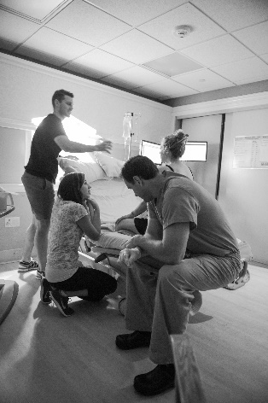
I will always respond to emails and texts as soon as possible. Please understand that my clients who are in labor or closer to their “guess date” (EDD) may take priority if your questions aren’t time-sensitive.
CONTRACT
$450.00 400.00_____Retainer fee due before or at first prenatal meeting
$450.00 400.00 _____Birth fee due at the last prenatal visit (postdated check is okay)

We, the undersigned, state that we have read and understand this doula contract and that it reflects the discussion we had with Karen about her services.

___________________________________ _______ _________________________________
Client Signature Date Partner’s Signature

___________________________________ _______
Doula’s Signature Date

